**Unmanned Ground**

**Vehicle (UGV) kit**

User Manual

 

Table of Contents

1. Components and Specifications 2

1.1. Vaman (Pygmy BB4) 2

1.2. ESP 32 2

1.3. Arduino Uno 2

1.4. Dual-Motor Driver IC on breadboard 2

1.5. DC motors 2

1.6. Ultrasonic sensor 2

1.7. UGV frame/chassis 2

1.8. AA batteries with holder. 2

2. Assembling the UGV kit 2

3. Exercise Programs 2

3.1. Navigation using ESP32 and Android Phone 2

3.2. Navigation using Vaman, ESP32 and Android Phone 2

3.3. Beacon tracking using ESP32 2

3.4. Beacon tracking using Vaman and ESP32 2

# Components and Specifications

## Vaman (Pygmy BB4)

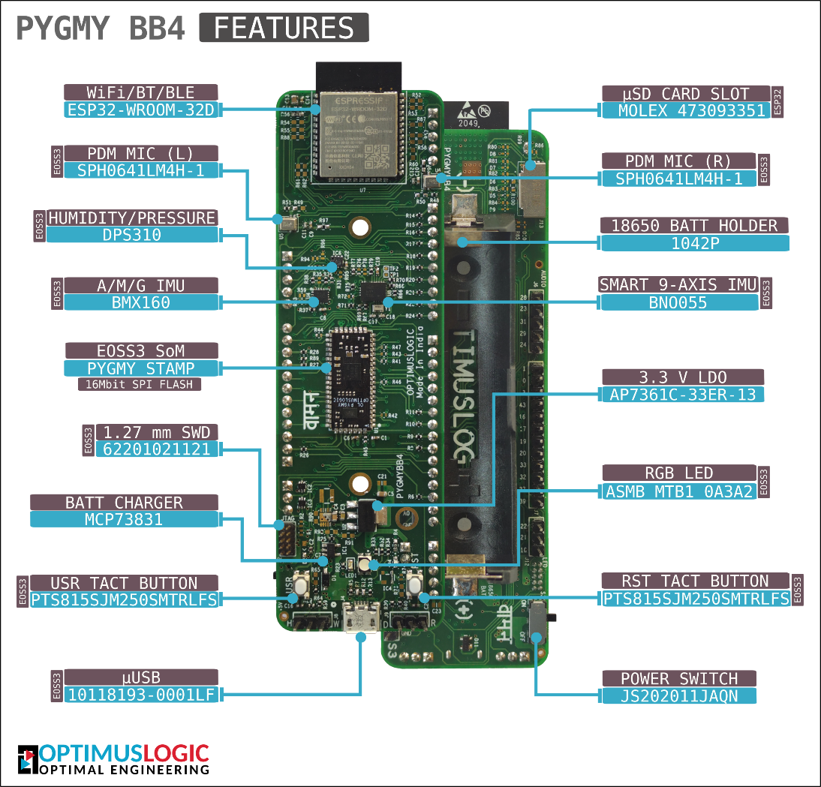

|  |  |  |
| --- | --- | --- |
| **SPECIFICATION FOR VAMAN CONTROLLER** | | |
| **Make** | Optimus Logic | |
| **Model** | Vaman (Pygmy BB4) | |
| **Sr No** | **Description** | |
|  | **General Data** | |
| 1 | Processors | E0SS3 SoM (ARM + FPGA dual processor) |
| 2 | Connectivity | Wi-Fi/BT/BLE connectivity with onboard ESP32 |
| 3 | Battery option | Yes |
| 4 | μSD card support | Yes (Connected to ESP32) |
| 5 | Onboard sensors | * BMX160 smart 9-Axis IMU * BNO055 smart fusion sensor * DPS310 provides Pressure, Humidity, and Temperature monitoring. * PDM MIC (L) & (R) |
| 6 | Buttons | User and reset button for programming the board |
| 7 | Connector | Micro-USB Type-B connector for connection to PC during programming and debugging. |

## ESP 32

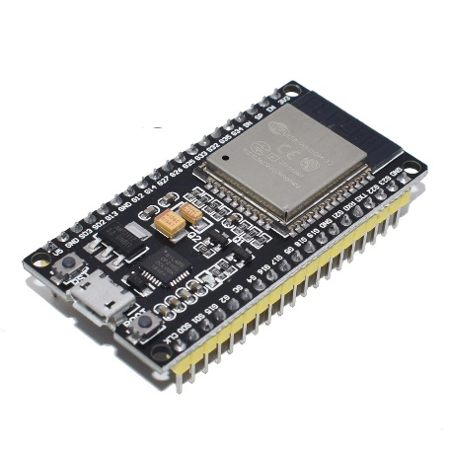

|  |  |  |
| --- | --- | --- |
| **SPECIFICATION FOR ESP32 CONTROLLER** | | |
| **Make** | Espressif Systems | |
| **Model** | ESP-WROOM-32 | |
| **Sr No** | **Description** | |
|  | **General Data** | |
| 1 | Processors | * CPU: Xtensa dual-core (or single-core) 32-bit LX6 microprocessor, operating at 160 or 240 MHz and performing at up to 600 DMIPS * Ultra-low-power (ULP) co-processor |
| 2 | Memory | * 320 KiB RAM, 448 KiB ROM |
| 3 | Connectivity | * Wi-Fi: 802.11 b/g/n * Bluetooth: v4.2 BR/EDR and BLE (shares the radio with Wi-Fi) |
| 4 | Peripheral interfaces | * 34 × programmable GPIOs * 12-bit SAR ADC up to 18 channels * 2 × 8-bit DACs * 10 × touch sensors (capacitive sensing GPIOs) * 4 × SPI * 2 × I²S interfaces * 2 × I²C interfaces * 3 × UART |
| 4 | Onboard sensors | * BMX160 smart 9-Axis IMU * BNO055 smart fusion sensor * DPS310 provides Pressure, Humidity, and Temperature monitoring. * PDM MIC (L) & (R) |
| 6 | Power management | * Internal low-dropout regulator * Individual power domain for RTC * 5 μA deep sleep current * Wake up from GPIO interrupt, timer, ADC measurements, capacitive touch sensor interrupt |
| 7 | Other features | * Motor PWM * LED PWM (up to 16 channels) * Hall effect sensor * Ultra-low-power analog pre-amplifier |

## Arduino Uno

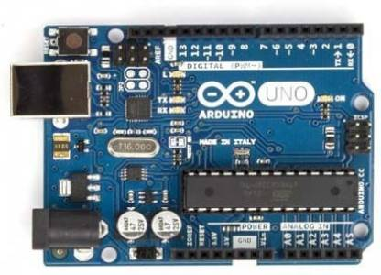

|  |  |  |
| --- | --- | --- |
| **SPECIFICATION FOR ARDUINO UNO** | | |
| **Make** | Arduino | |
| **Model** | Arduino Uno | |
| **Sr No** | **Description** | |
|  | **General Data** | |
| 1 | Microcontroller | ATmega328P |
| 2 | Operating Voltage | 5V |
| 3 | Input Voltage (recommended) | 7-12V |
| 4 | Input Voltage (limit) | 6-20V |
| 5 | Digital I/O Pins | 14 (of which 6 provide PWM output) |
| 6 | PWM Digital I/O Pins | 6 |
| 7 | Analog Input Pins | 6 |
| 8 | DC Current per I/O Pin | 20 mA |
| 9 | DC current for 3.3V Pin | 50 mA |
| 10 | Flash Memory | 32 KB (ATmega328P) of which 0.5 KB used by bootloader |
| 11 | SRAM | 2 KB (ATmega328P) |
| 12 | EEPROM | 1 KB (ATmega328P) |
| 13 | Clock Speed | 16 MHz |
| 14 | LED_BUILTIN | 13 |
| 15 | Length | 68.6 mm |
| 16 | Width | 58.4 mm |
| 17 | Weight | 25 g |

## Dual-Motor Driver IC on breadboard

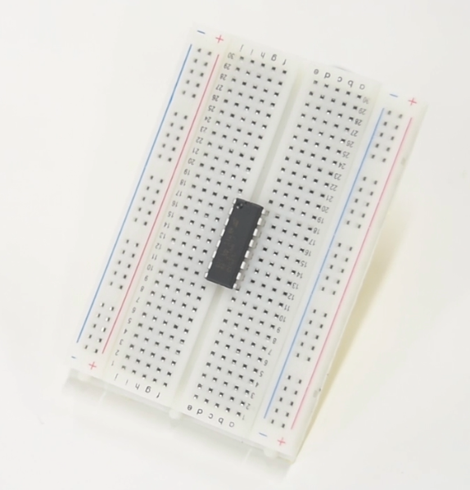

|  |  |  |
| --- | --- | --- |
| **SPECIFICATION FOR DUAL MOTOR DRIVER IC** | | |
| **Make** | Texas Instruments | |
| **Model** | L293D | |
| **Sr No** | **Description** | |
|  | **General Data** | |
| 1 | Wide Supply-Voltage Range | 4.5 V to 36 V (for VVC2 motor supply) |
| 2 | IC power supply (VCC1 pin) | 5 V |
| 3 | Number of supported motors | 2 DC motors |
| 4 | Output Current | 600 mA Per Channel |
| 5 | Peak Output Current | 1.2 A Per Channel |
| 6 | Operation Temperature | 0°C to 70°C. |
| 7 | Other features | * Direction and speed control of two motors * Separate Input-Logic Supply * Internal ESD Protection * High-Noise-Immunity Inputs * Output Clamp Diodes for Inductive Transient Suppression * Automatic thermal shutdown is available |

## DC motors

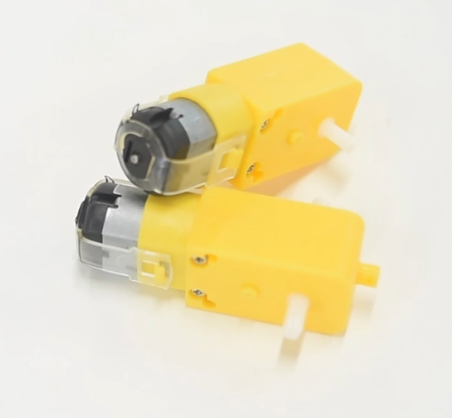

|  |  |  |
| --- | --- | --- |
| **SPECIFICATION FOR DC MOTORS** | | |
| **Make** | Robo India | |
| **Model** | DC motor | |
| **Sr No** | **Description** | |
|  | **General Data** | |
| 1 | Supply Voltage | 9V DC |
| 1 | Type | Brushed motor |
| 2 | Operating speed | Upto 300 RPM |
| 3 | Efficiency | 60-75 % with high starting torque |

## Ultrasonic sensor

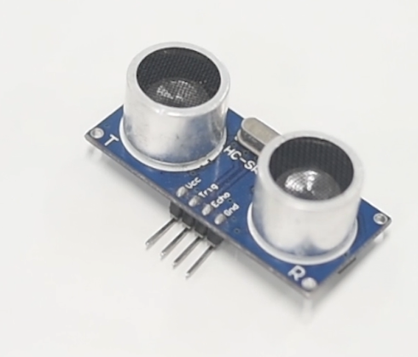

|  |  |  |
| --- | --- | --- |
| **SPECIFICATION FOR ULTRASONIC CONTROLLER** | | |
| **Make** | Arduino | |
| **Model** | HCSR04 | |
| **Sr No** | **Description** | |
|  | **General Data** | |
|  | Input Voltage | 5V |
|  | Current Draw | 20mA (Max) |
|  | Digital Output | 5V |
|  | Digital Output | 0V (Low) |
|  | Working Temperature | -15°C to 70°C |
|  | Sensing Angle | 30° Cone |
|  | Angle of Effect | 15° Cone |
|  | Ultrasonic Frequency | 40kHz |
|  | Range | 2cm - 400cm |
|  | **Dimensions** | |
|  | Length | 43mm |
|  | Width | 20mm |
|  | Height (with transmitters) | 15mm |
|  | Centre screw hole distance | 40mm x 15mm |
|  | Screw hole diameter | 1mm (M1) |
|  | Transmitter diameter | 8mm |

## UGV frame/chassis

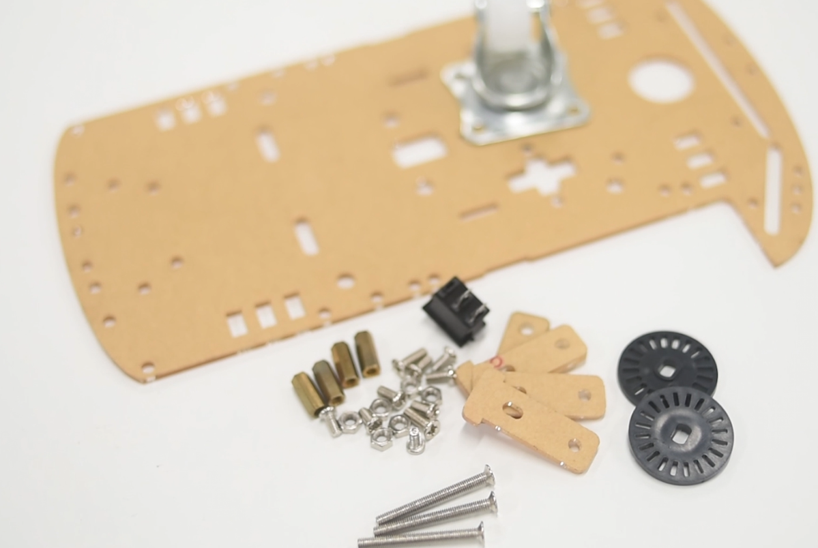

|  |  |
| --- | --- |
| **SPECIFICATION FOR CHASIS** | |
|  | **General Data** |
|  | ● High-quality acrylic material  ● Suitable for 2-wheel design.  ● Supports universal Castor wheel  ● All necessary screws & nuts |

## Batteries for powering various equipment

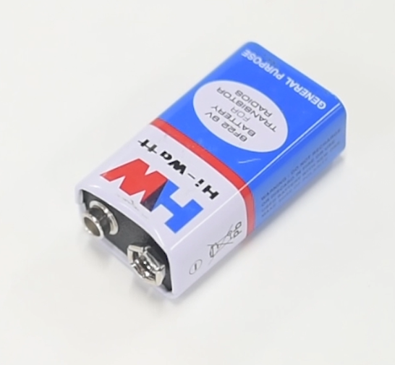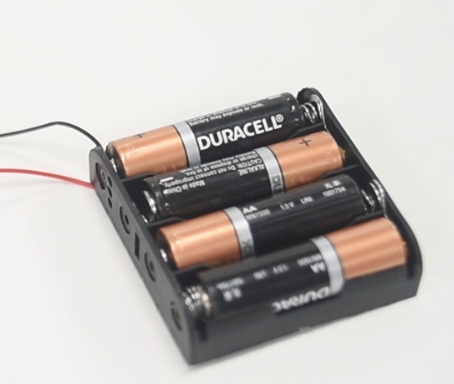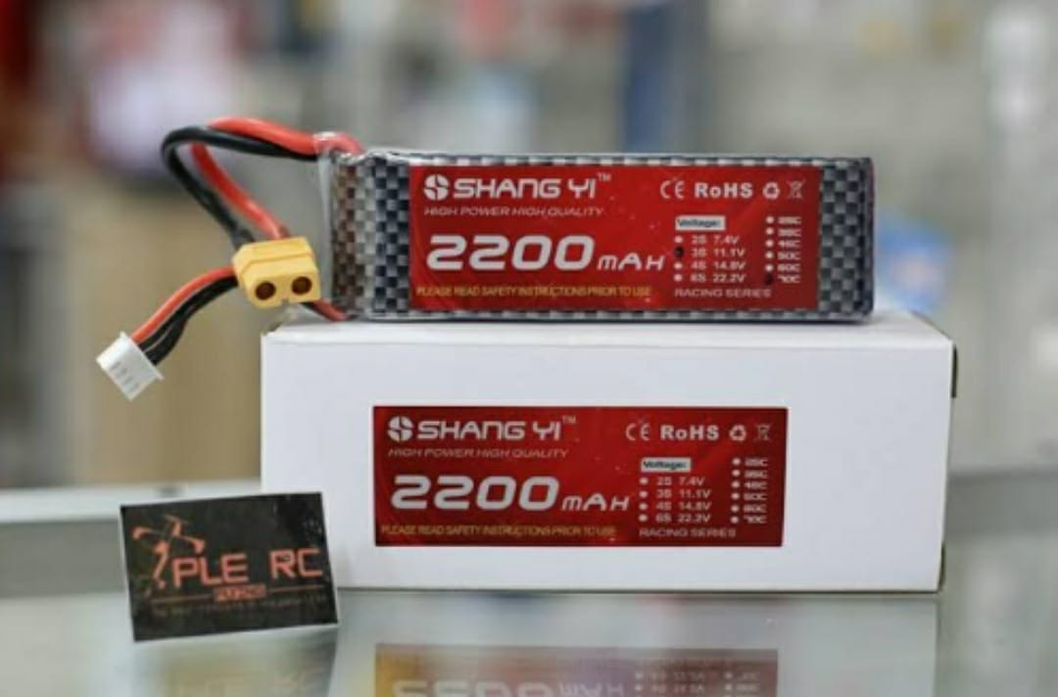

|  |  |  |
| --- | --- | --- |
| **SPECIFICATION FOR BATTERIES** | | |
| **Sr No** | **Description** | |
|  | **9 V Battery** | |
| 1 | Voltage supply | 9V |
| 2 | Rechargeable | No |
| 3 | Relevant components | DC motors |
|  | **AA battery** | |
| 1 | Voltage supply | 1.5 x 4 Volts (6 V) |
| 2 | Rechargeable | No |
| 3 | Relevant components | Supply for Motor driver IC and External ESP32 |
|  | **Li-Po Battery** | |
| 1 | Voltage supply | 11.2 V |
| 2 | Rechargeable | Yes |
| 3 | Relevant components | For DC motors |

# Assembling the UGV kit

* Step 1: Assemble the Chassis using the provided nuts/screws, Wheels, and parts.

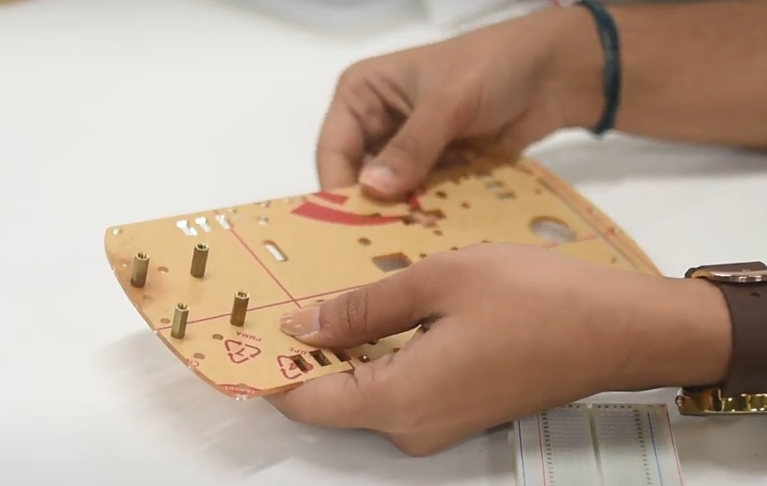

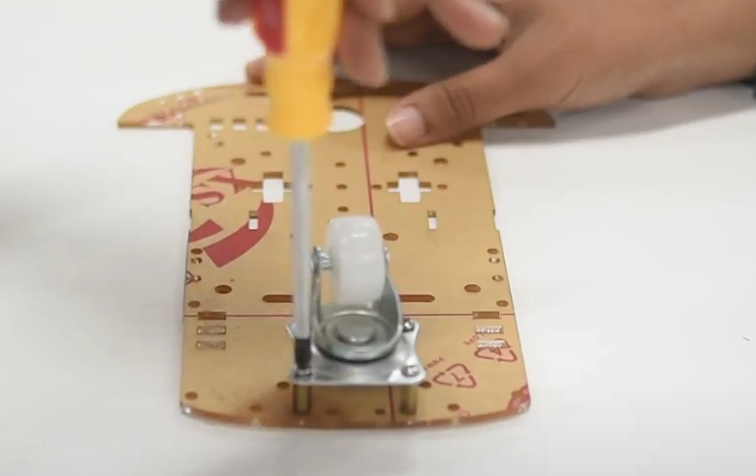

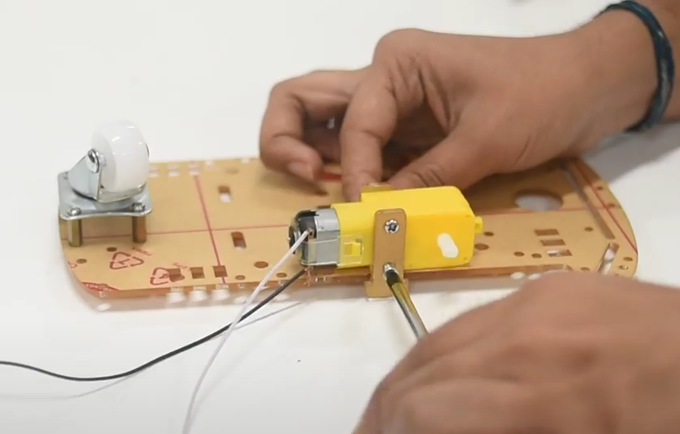

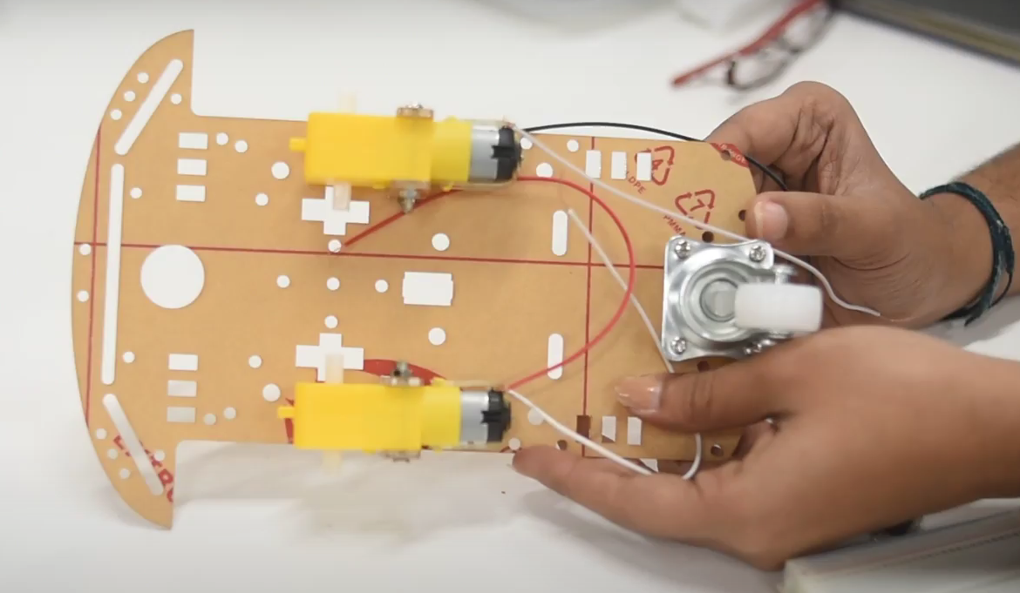

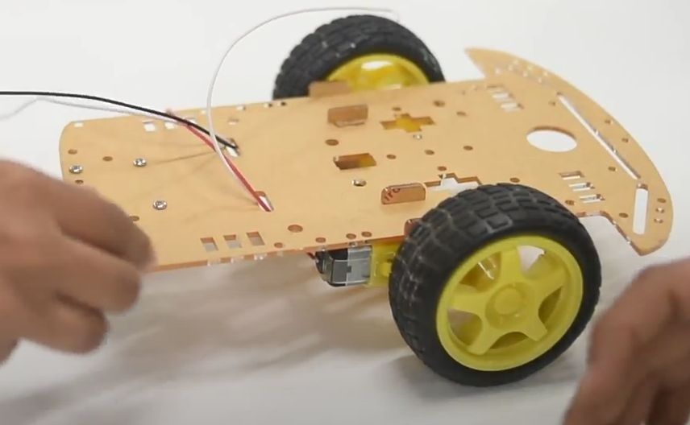

* Step 2:
  + Fix the Vaman controller and ESP32 on the chassis.
  + Fix the Dual motor driver IC along with a small breadboard on the chassis.
  + Fix the Li-Po battery on the chassis and insert AA batteries in the battery holder.

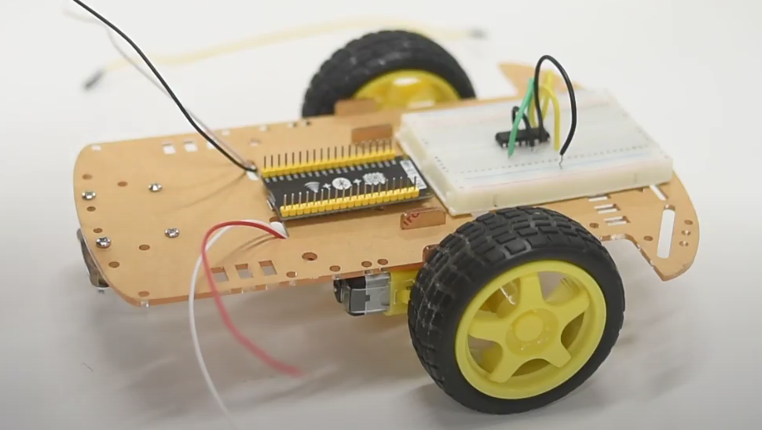

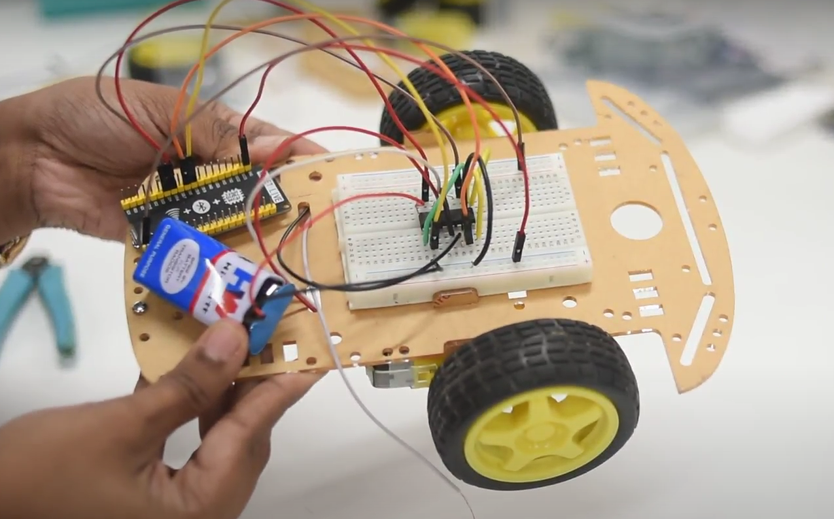

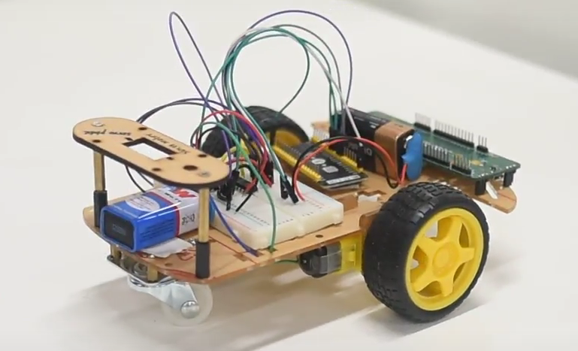

* Step 5:
  + Refer to the Exercise programs (section 3) for guide on wiring connection and programming of the controllers for the desired application.
  + Connect the battery supply and turn on the power to various equipment.
* Step 6:
  + Download the “dabble” application from the play store on an Android phone.
  + Using dabble application, connect to the ESP32 on the UGV kit using Bluetooth connection.
  + Control the navigation of the UGV kit using the GUI controls on the dabble application.

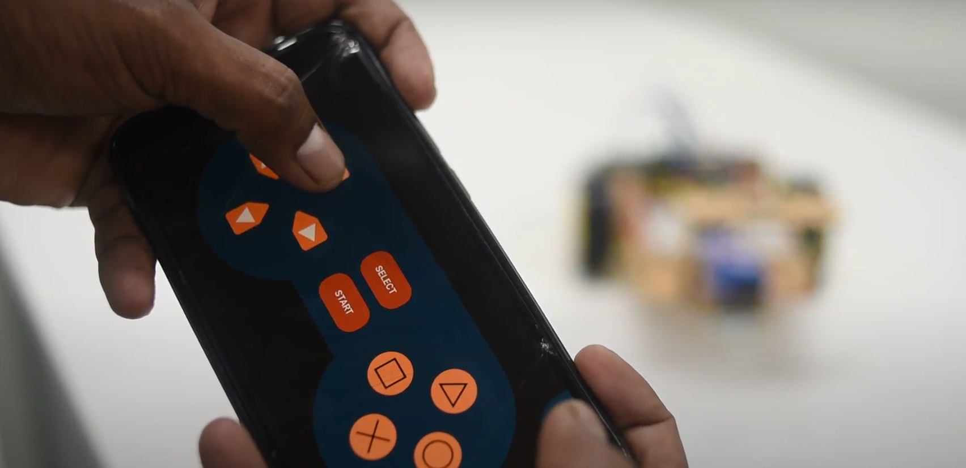 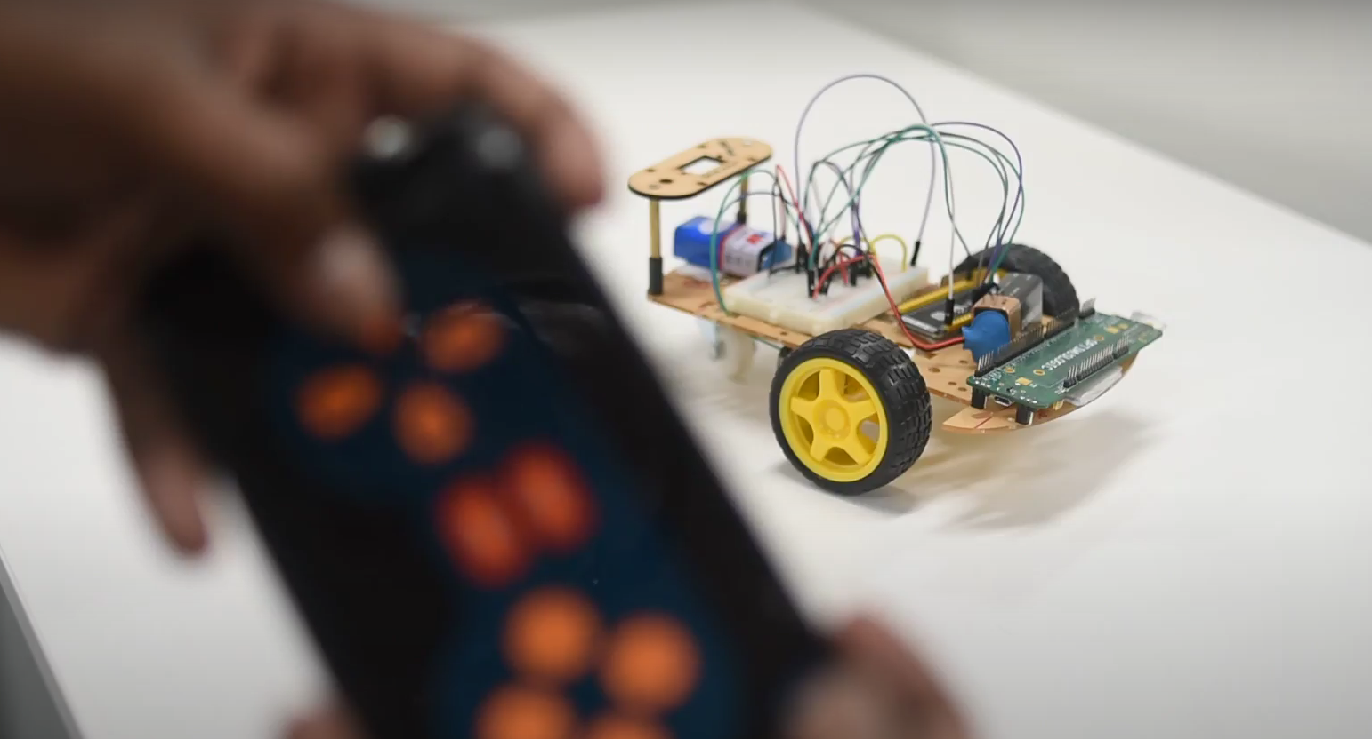

# Exercise Programs

## Navigation using ESP32 and Android Phone

### Connection diagram:

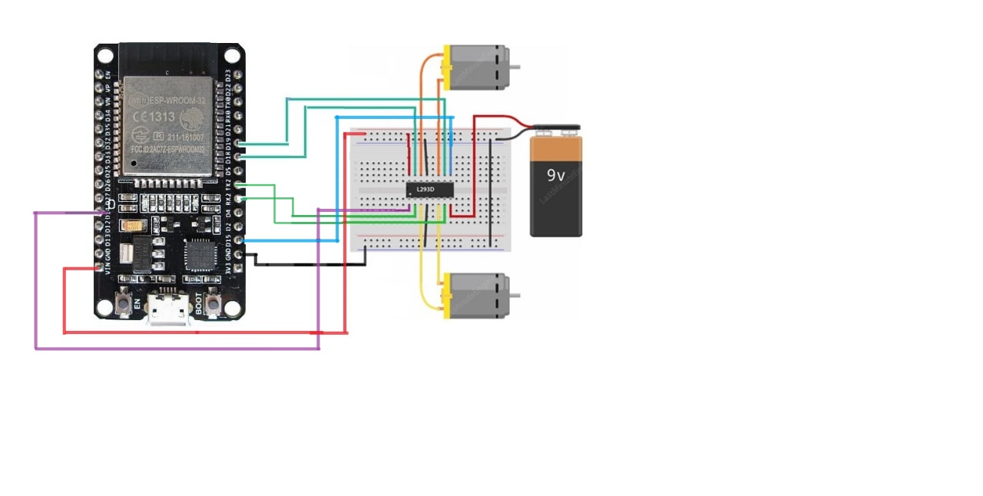

Figure 1 - Connection diagram

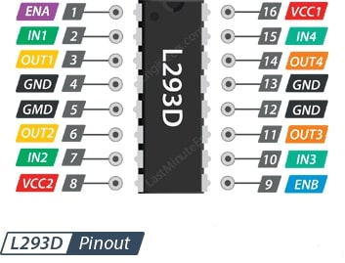

Figure 2 - Pin diagram of L293D Motor driver IC

### Wiring description

* Refer the pin diagram of L293D motor driver IC
* Connect VCC1 pin to Vin pin on ESP32.
* The input and enable pins (ENA, IN1, IN2, IN3, IN4 and ENB) of the L293D IC are connected to six ESP32 digital output pins (14, 16, 17, 18, 19 and 15).
* Connect one motor across the OUT1 & OUT2 pins of IC and the other motor across the OUT3 & OUT4 pins of IC.
* Connect external 9V battery to the VCC2 pin of L293D motor driver IC.
* Connect external GND pin battery to the GND pin of L293D motor driver IC.
* Go to Arduino IDE and Write the following code:

<https://github.com/sachinomdubey/Projects/blob/main/Autonomous%20Navigation/ESP32/IDE/UGV_navigation_using_android_phone/Codes/UGV_navigation_using_android_phone.ino>

* Click on Compile and Upload the code to” DOIT ESP32 DEVKITV1”.
* Now open Dabble app search for Bluetooth devices and Select” MyEsp32” and connect it.
* After connecting click on Gamepad Icon and you will get control panel.

### Codes (GitHub link)

<https://github.com/sachinomdubey/Projects/tree/main/Autonomous%20Navigation/ESP32/IDE/UGV_navigation_using_android_phone/Codes>

## Navigation using Vaman, ESP32 and Android Phone

## Beacon tracking using ESP32

## Beacon tracking using Vaman and ESP32